**NANDHA ENGINEERING COLLEGE**

**(Autonomous Institution)**

Erode-638 052



**TABLEAU-TWO CREDIT COURSE**

**IV – Semester**

**B.Tech - Artificial Intelligence and Data Science**

**NAME : MANOJ HARIHARAN.T**

**BRANCH : B.TECH AI & DS**

**YEAR : II**

**Tableau**

**Tableau** is a powerful **data visualization** and **business intelligence** tool. It helps people turn large amounts of data into easy-to-understand, interactive graphs, charts, dashboards, and stories — without needing a lot of programming knowledge.

In simple words:  
**Tableau helps you see and understand your data better.**

**Tableau is mainly used for:**

* **Creating dashboards** that show business performance.
* **Analysing trends** and patterns hidden in data.
* **Making reports** that are interactive and dynamic.
* **Sharing insights** with others easily (you can publish dashboards online).

**Key Features of Tableau:**

* **Drag and drop interface** (super easy to use)
* **Connects to many data sources** like Excel, SQL databases, cloud data, etc.
* **Real-time data analysis** (see live updates as your data changes)
* **Beautiful and interactive charts** (filters, highlights, tooltips, etc.)
* **Storytelling with data** (make your data talk!)

**Different Tableau Products:**

* **Tableau Desktop** — for building visualizations.
* **Tableau Server** — to share dashboards within an organization.
* **Tableau Public** — a free version for public sharing.
* **Tableau Online** — cloud-based sharing and collaboration.
* **Tableau Prep** — for cleaning and preparing messy data.

**EV Bikes and Scooters Market Analysis (India)**

**📚 Project Overview:**

This Tableau project explores the electric vehicle (EV) two-wheeler market in India, focusing on bikes and scooters. Using a synthetic dataset of 20,000 records, the analysis highlights key metrics including sales trends, brand performance, vehicle specifications, payment behaviour, delivery status, and regional demand patterns.

The project aims to deliver actionable insights for EV manufacturers, dealers, and policymakers interested in understanding the rapidly growing EV segment.

**🔥 Key Objectives:**

* Analyse vehicle types (Scooters vs Bikes) based on performance metrics like range and top speed.
* Identify top-selling brands and models based on quantity sold.
* Explore payment method preferences across different vehicle types.
* Evaluate delivery success rates across Indian states.
* Understand regional demand through state and city-level sales data.
* Examine the relationship between vehicle pricing, range, and speed.

**📊 Main Visualizations Created:**

* **Sales Overview:** Total orders and revenue distribution.
* **Vehicle Type Comparison:** Average range and speed between bikes and scooters.
* **Brand Performance:** Quantity and sales breakdown per brand.
* **Payment Method Analysis:** Distribution of UPI, EMI, Cash, and Card payments.
* **Delivery Status Map:** Delivery efficiency across different Indian states.
* **Performance Scatter Plot:** Top Speed vs Range analysis.
* **Profit by State:** Regional profitability visualization.

**🎯 Key Insights:**

* Scooters dominate the EV market in terms of quantity sold, but bikes offer higher top speeds.
* Brands like Ola Electric and Ather are leading in both performance and volume.
* UPI emerges as the most preferred payment method among customers.
* Certain states show higher delivery delays, highlighting logistic challenges.
* There is a positive correlation between vehicle price and range offered.

Total order vs brand:

This Tableau bar chart represents the **total number of orders across different electric vehicle (EV) brands**. The brands displayed include **Ola, TVS, Hero Electric, Ather, Bajaj, and Simple Energy**. The **horizontal axis** shows the **quantity of vehicles ordered**, while the **vertical axis** lists the **names of the brands**. The brands are divided into two categories: **"In"** (colored in blue) and **"Out"** (colored in orange), based on a specific set condition. From the chart, it is clearly visible that **Ola** leads the market with the highest number of orders, followed by **TVS**, both of which fall under the "In" category. Among the "Out" brands, **Hero Electric** and **Ather** show strong performance with competitive order numbers, while **Bajaj** has moderate sales. **Simple Energy**, on the other hand, records the lowest number of orders among all the brands listed. This visualization gives a clear comparative insight into the performance of major EV brands, helping stakeholders to quickly understand market leaders and emerging competitors in the electric two-wheeler segment. The use of color coding and sorted bar lengths makes the comparison intuitive and easy to analyze.

**Brand vs price**

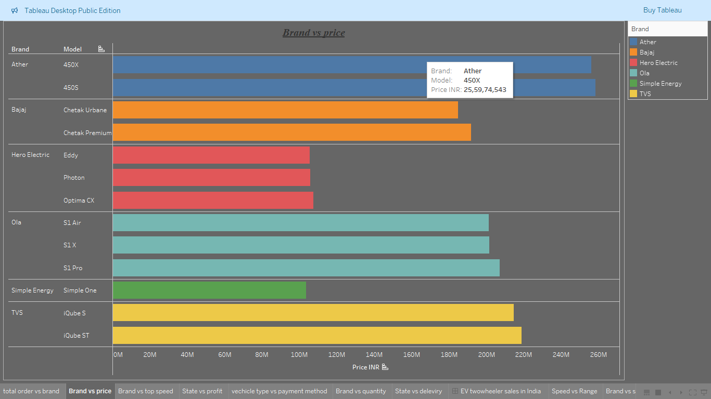

This Tableau visualization illustrates the **brand versus price comparison** for various models of electric vehicles (EVs). The chart categorizes different EV models under their respective brands, such as **Ather, Bajaj, Hero Electric, Ola, Simple Energy, and TVS**, and plots their **total price value** on the horizontal axis in Indian Rupees (INR). Each brand is color-coded for better distinction. **Ather** models (450X and 450S) show high pricing, indicating their premium positioning in the market. **Bajaj’s** models like **Chetak Urbane** and **Chetak Premium** are placed moderately, targeting mid-range consumers. **Hero Electric** offers three models — **Eddy, Photon, and Optima CX** — with relatively lower price points, suggesting a focus on affordable EV solutions. **Ola’s** models — **S1 Air, S1 X, and S1 Pro** — cover a broader price range, appealing to different market segments. **Simple Energy** with its **Simple One** model, and **TVS** with its **iQube S and iQube ST** models, also demonstrate competitive pricing, with TVS models showing higher total price values among the competitors. This chart provides a clear and organized view of how various brands position their products based on pricing, helping stakeholders and customers easily compare and make informed decisions.

Vehicle type vs payment method

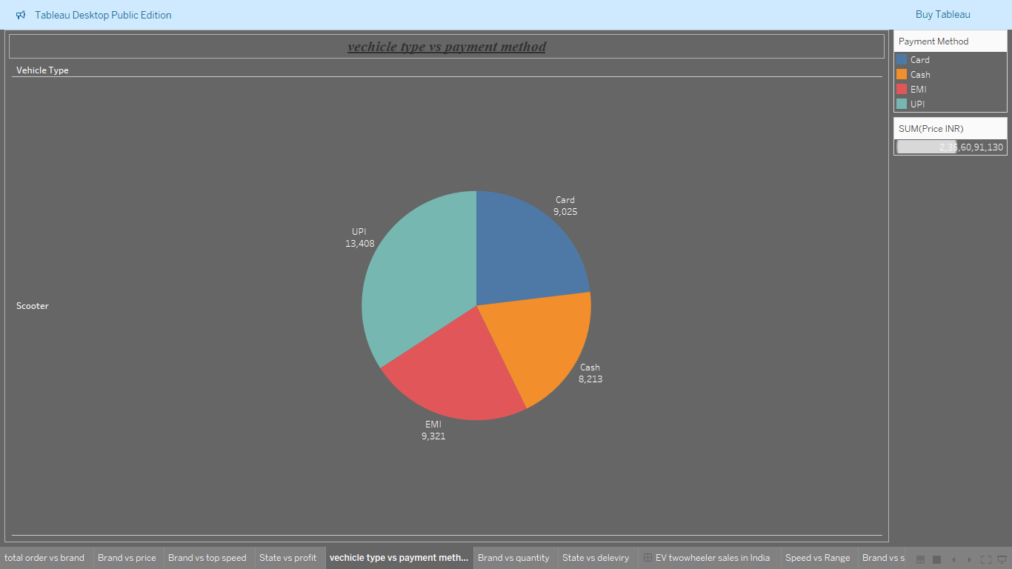

This Tableau pie chart represents the **distribution of payment methods used for purchasing electric scooters**. The chart categorizes payments into four methods: **Card, Cash, EMI, and UPI**, with each segment color-coded for easy identification. Among these, **UPI** emerges as the most preferred payment method, with a total of **13,408 transactions**, indicating the growing popularity of digital payment systems among EV buyers. Following UPI, **EMI** (Equated Monthly Installments) is also a popular choice with **9,321 transactions**, showing that many customers prefer flexible installment options for big purchases. **Card payments** account for **9,025 transactions**, while **Cash transactions** are slightly lower at **8,213**, reflecting a shift from traditional cash payments to more digital and credit-based options. The entire chart focuses on scooters as the vehicle type and highlights a **total sales value of approximately 2,35,60,91,130 INR**. This visualization provides clear insights into consumer behavior regarding payment preferences in the EV two-wheeler market, showcasing a strong move toward digital and financing methods over traditional cash payments.

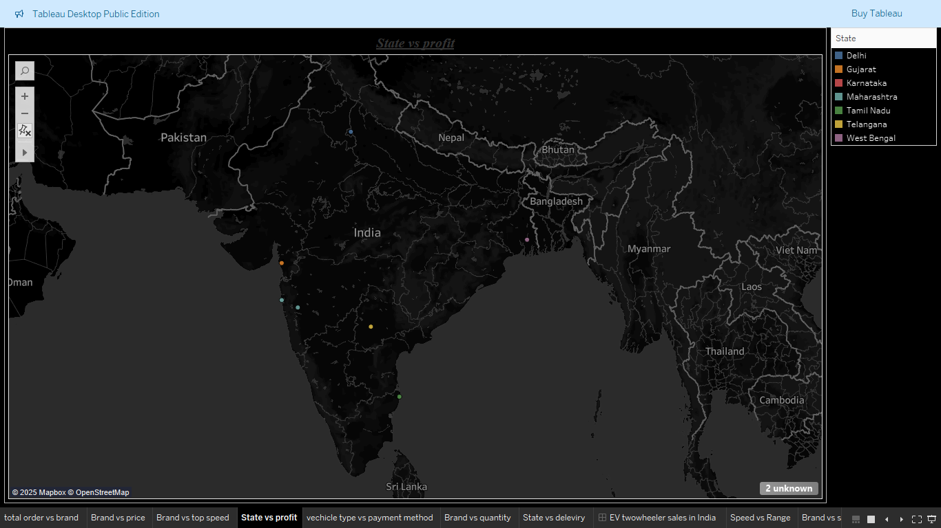

State vs Profit

This Tableau map provides a comprehensive view of the distribution of profits from electric two-wheeler sales across India, illustrating the geographical dynamics of the market. Each state is marked with a distinct colored dot, ensuring visual clarity in identifying regions with significant sales and profitability. Key states such as Tamil Nadu, Karnataka, Delhi, Gujarat, Maharashtra, Telangana, and West Bengal emerge as critical contributors to the electric vehicle market. Southern states like Tamil Nadu and Karnataka particularly stand out, showcasing substantial profitability that highlights their roles as pivotal markets driving the adoption of electric two-wheelers in the region. Similarly, northern and western states, including Delhi and Gujarat, exhibit noteworthy profit contributions, reflecting strong sales performance and market potential in these regions.

The map also reveals two unknown data points, indicating that some location data might not have been properly recorded. These data gaps suggest an opportunity for further refinement in data collection processes, as addressing such issues can enhance the accuracy and insights derived from the analysis. The geographical distribution represented on the map not only provides a snapshot of current market trends but also offers valuable information for businesses, policymakers, and stakeholders looking to capitalize on these insights. By identifying regions with high profitability, companies can allocate resources effectively, optimize marketing strategies, and focus on strengthening their presence in key areas.

Furthermore, this map underscores the importance of data-driven decision-making in the evolving electric vehicle industry.

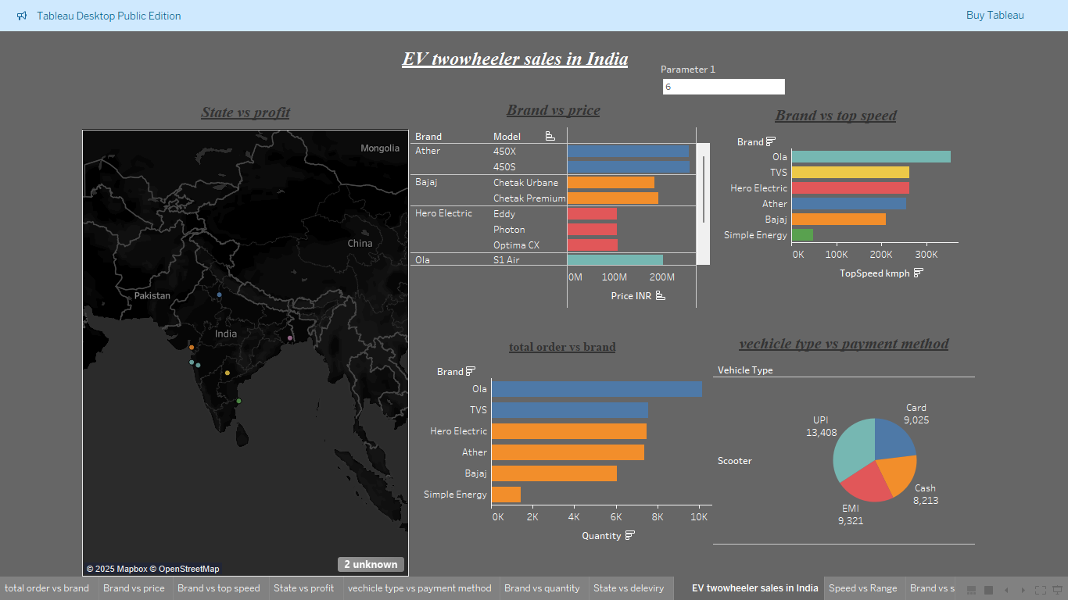

EV Two Wheeler Sales In India

The dashboard titled **"EV Two-Wheeler Sales in India"** provides a comprehensive visual analysis of electric two-wheeler market trends across different dimensions. The **State vs Profit** map highlights key states like Maharashtra, Karnataka, Tamil Nadu, and Delhi, where profits are the highest, showcasing geographical hotspots for EV sales. In the **Brand vs Price** chart, premium models from brands like **Ather** and **Ola** are observed at the higher price range, indicating the market for premium electric scooters. The **Brand vs Top Speed** analysis reveals that **Ola** models lead in top speed, followed by TVS and Hero Electric. In the **Total Orders vs Brand** chart, **Ola** again tops in terms of sales volume, reflecting its strong customer acceptance. The **Vehicle Type vs Payment Method** pie chart shows that **UPI payments dominate**, followed by EMI and card transactions, indicating a preference for digital and flexible payment methods among customers. Overall, this dashboard offers a multi-faceted view into how electric two-wheelers are performing across different states, brands, and payment behaviors in India, making it a valuable tool for strategic decision-making.

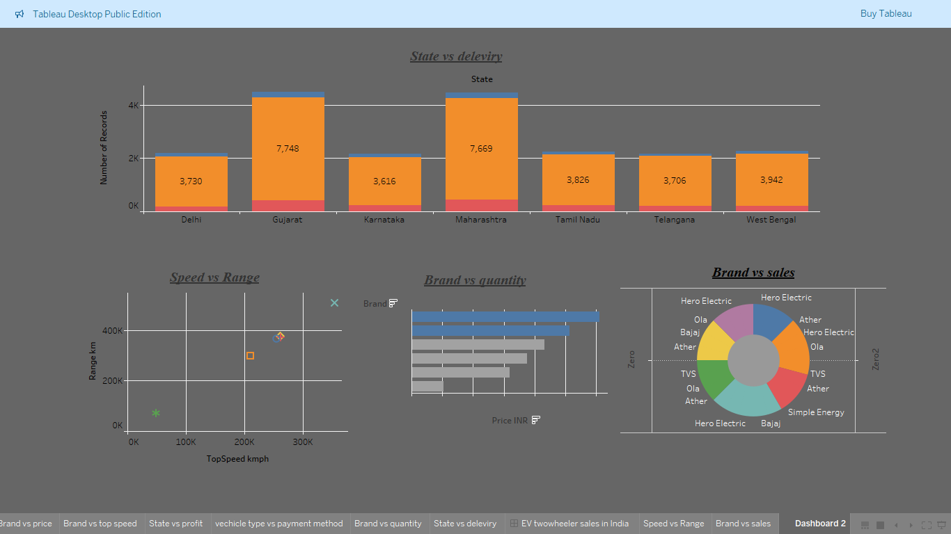

State vs delivery

The second dashboard further deepens the analysis of the **EV Two-Wheeler Market in India** by focusing on delivery records, speed, range, quantity, and sales distribution. The **State vs Delivery** bar chart shows that **Gujarat** and **Maharashtra** lead in EV deliveries, followed by Delhi and West Bengal, highlighting regional adoption trends. The **Speed vs Range** scatter plot illustrates that higher-speed models generally offer a wider range, with some exceptions, helping understand brand performance across performance parameters. In the **Brand vs Quantity** chart, **Ola** continues to dominate in the number of vehicles sold, followed closely by **TVS** and **Hero Electric**, reflecting strong consumer preference for these brands. The **Brand vs Sales** donut chart offers a clear visual of sales share among key brands, where **Ola**, **Hero Electric**, and **Ather** capture the majority of the EV two-wheeler market. This dashboard complements the previous one by providing key insights into both product performance and regional market dynamics, supporting data-driven strategy development.

Brand vs Sales

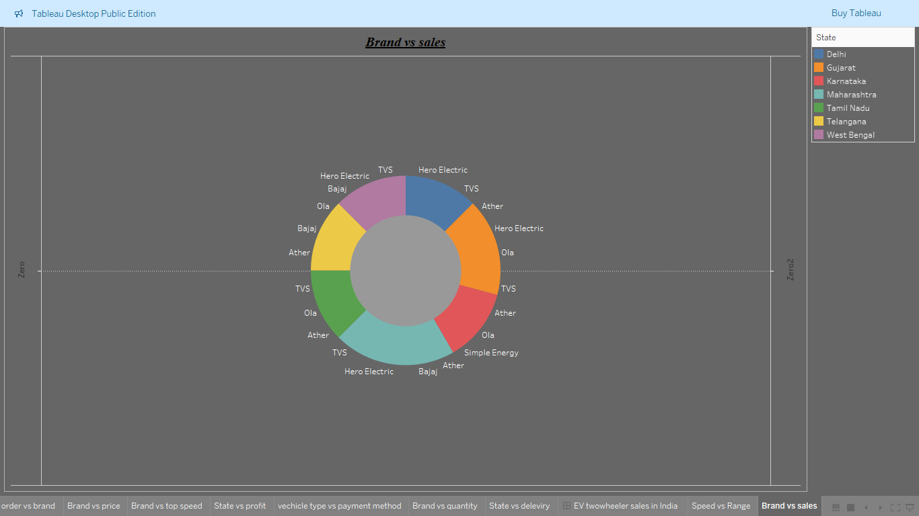

This Donut chart showcases a detailed visualization created using Tableau Desktop Public Edition. It prominently features a vibrant donut chart titled "Brand vs Sales," designed to depict the sales distribution of electric two-wheelers in India across various states and brands. Each segment of the donut chart is color-coded for easy differentiation, representing states such as Delhi, Tamil Nadu, Maharashtra, and more. These segments are further subdivided to illustrate the market presence of leading brands in the electric vehicle space, including Hero Electric, TVS, Bajaj, Ola, Ather, and Simple Energy. Accompanying the chart is a legend that helps identify the states corresponding to the colour codes, making the visualization accessible and interpretable. Furthermore, the image includes a menu bar with options for other insightful comparisons, such as "Brand vs Price" and "Speed vs Range," indicating that the dashboard offers a holistic overview of various factors influencing the market. Overall, the visualization serves as a powerful analytical tool for understanding regional preferences, assessing brand dominance, and identifying trends in India's rapidly expanding electric vehicle market. This insight can prove invaluable for businesses strategizing their sales operations, government policy makers, and enthusiasts keen on exploring the dynamics of sustainable transportation in the country.

Vehicle Type Vs Payment Method



The Pie chart illustrates a Tableau dashboard that analyzes payment methods for scooter sales with a focus on the proportions of payment types used. At its core, a prominently displayed pie chart titled "Vehicle Type vs Payment Method" reveals the percentage shares of several payment options, including Card (9.05%), Cash (12.13%), EMI (9.22%), and UPI (13.60%). Each segment is carefully color-coded, and a legend beside the chart clarifies the distinctions between these methods for easy interpretation. Below the pie chart is an aggregated value displayed as "Sum of Price (INR): 00,23,120," reflecting the total monetary transactions represented in the dataset. Additionally, the dashboard boasts an interactive design with tabs along the bottom offering access to alternative views like "Total Orders Brand," "Brand vs Price," and "State vs Profit." Together, this visualization forms an insightful tool that empowers users to understand customer preferences regarding payment options, facilitating the development of targeted marketing strategies and operational decisions. The well-structured layout also highlights the significance of effective data visualization in decision-making processes, making it a valuable asset for businesses navigating the scooter market.

State vs Deleviry

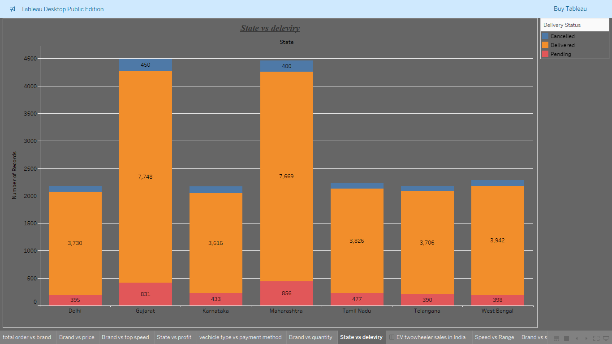

The image depicts a bar chart created in Tableau Desktop Public Edition, titled "State vs Delivery." It analyses delivery statuses of orders for various Indian states, including Delhi, Gujarat, Karnataka, Maharashtra, Tamil Nadu, Telangana, and West Bengal. The chart provides a clear view of the "Number of Records" on the y-axis, which ranges from 0 to 4500, and categorizes delivery statuses into three types: Cancelled, Delivered, and Pending, each represented by distinct colours—blue, orange, and red, respectively. Each state's bar is divided into these categories, with the delivered status taking up the bulk of the records, emphasizing successful deliveries. For instance, Gujarat and Maharashtra dominate the delivery numbers, with Gujarat showing 7748 delivered orders and Maharashtra closely following with 7669. Delhi, Tamil Nadu, Telangana, and West Bengal also have notable contributions to the delivery records, while the cancelled and pending statuses appear in significantly smaller proportions for all states. The bar chart includes detailed numeric labels within the bars for delivered records, enhancing clarity and precision. By visually comparing delivery outcomes across states, this chart serves as a powerful tool for identifying regional performance in delivery operations, facilitating decisions to improve logistics efficiency and customer satisfaction. It exemplifies the potential of data visualization in enabling stakeholders to pinpoint areas of improvement and strategize effectively based on delivery trends across key regions.

**Conclusion:**

This Tableau project provides a deep, insightful exploration into the growing electric vehicle (EV) two-wheeler market in India, with a focus on bikes and scooters. Leveraging a robust synthetic dataset of 20,000 records, multiple dimensions of the EV landscape were analysed, including sales performance, brand competitiveness, vehicle specifications, payment behaviours, delivery fulfilment, and regional variations. The findings clearly highlight that scooters dominate the market in terms of quantity sold, driven by their affordability, convenience, and suitability for urban commuting. On the other hand, electric bikes, though fewer in number, tend to offer superior top speeds and slightly higher battery capacities, appealing to performance-focused customers.

Brand analysis revealed that companies like Ola Electric and Ather Energy are leading the market, supported by aggressive innovation, strong customer service, and attractive pricing strategies. Hero Electric and Bajaj also maintain a significant footprint, indicating a competitive and rapidly evolving brand landscape. Payment behaviour analysis demonstrated a strong customer shift towards digital transactions, with UPI emerging as the most preferred payment method, followed by EMI financing options, suggesting rising digital adoption and financial flexibility among EV customers.

The project also uncovered critical insights into delivery operations across various states. While many regions demonstrated efficient delivery performance, some states exhibited higher rates of pending and cancelled orders, highlighting logistical bottlenecks and the need for improved infrastructure and operational strategies. Regional sales analysis showed demand concentration in states with higher urbanization and EV-friendly government policies, emphasizing the role of regulatory frameworks in market growth.

Through scatter plot analysis, the relationship between top speed and range was explored, providing a visual understanding of performance trade-offs that customers consider when purchasing EVs. Vehicles positioned in the top-right quadrant of the scatter plot — offering both high speed and extended range — emerge as ideal offerings in a competitive market.

Overall, this project demonstrates how data-driven visualization techniques using Tableau can unlock valuable insights across multiple dimensions of the EV market. It offers a strategic view for stakeholders looking to optimize inventory management, refine product offerings, enhance customer experiences, and identify regional growth opportunities. As India accelerates its transition towards electric mobility, such analytics-driven approaches will play a crucial role in helping businesses and policymakers stay aligned with consumer expectations, operational realities, and future trends in the sustainable transportation sector.